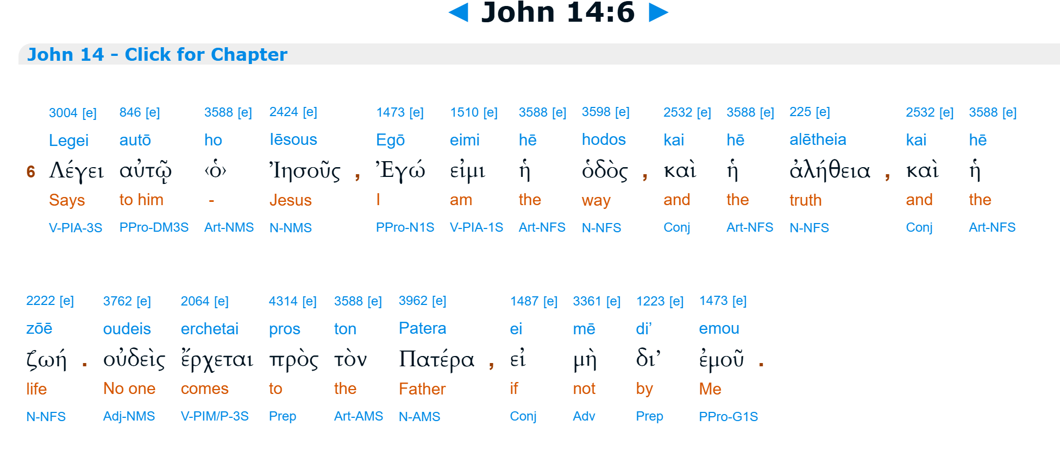

Throughout my entire life this verse has bothered me more than any other in the entire Bible. Even as a child I thought about how much suffering the story contains and when John’s Jesus finally gives us that Good News, he immediately makes a claim of exclusivity? But what about all those people that never even heard of Jesus, I would ask the adults, and they would stammer something convoluted that they clearly didn’t quite understand themselves.
Here I purpose a new reading, one that could perhaps help reshape Christianity for the post-modern world, a reading, and a Christianity that is not transactional but one that is transformational.

